**ASSIGNMENT-05 22/7/2023**

METHODS IN JAVA:

Methods are the set of the statement used to perform a particular task.

If a method as to be executed it as to be called by using its main.

In general, a**method** is a way to perform some task . Similarly, the **method in Java** is a collection of instructions that performs a specific task. It provides the reusability of code. We can also easily modify code using **methods.**

Based on whether a method is accepting the parameter and returning the value or not(taking the input and giving the output or not).Methods are classified into four types.

**Type 1: Method**

No i/p No o/p

Methods which would not accept any parameters and would not return any value.

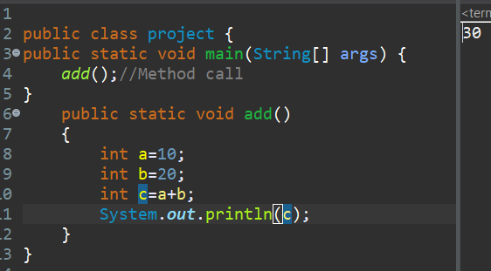

**Type 2: Method**

No i/po/p

Methods which would not accept any parameters and would return any value. 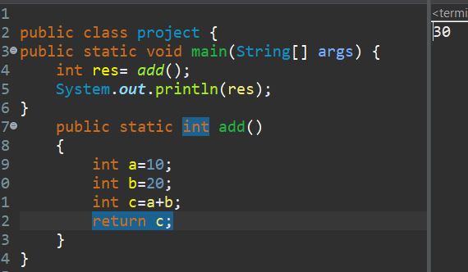

**Type 3: Method**

I/p No o/p

Methods which would accept any parameters and would not return any value.

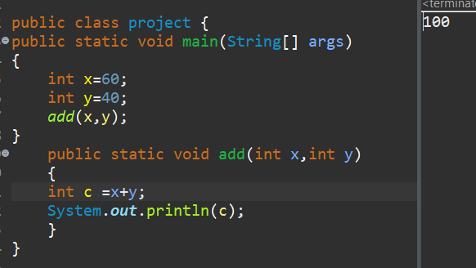

**Type 4: Method**

i/p o/p

Methods which would accept any parameters and would return any value. 